
Oesophageal Physiology Report

Dr Jafar Jafari MD, PhD, AGIP
Address: 27 Tooley St, London SE1 2PR, Tel: 079 506 588 02, e-Mail: jafar.jafari@nhs.net

Physician:
Mr James Gossage
Consultant GI Surgeon
Patient:
Mr WEST, Simon
E2448278

Report date: 14/01/2020
Procedure: High resolution manometry (HRM)
Indications: Heller’s and Dor’s: 2008, recent dysphagia

Lower Esophageal Sphincter Region |  | Normal | Esophageal Motility |  | Normal
Landmarks |  |  | Number of swallows evaluated | 10
Proximal LES (from nares)(cm) | 50.0 |  | Evaluated @ 3.0 - 11.0 above LES
LES length(cm) | 4.0 | 2.7-4.8 | Peristaltic (velocity ≤ 6.25 cm/s)(%) | 0
Esophageal length (LES-UES centers)(cm) | 29.0 |  | Simultaneous (vel. ≥ 6.25 cm/s)(%) | 0 | ≤10%
Intraabdominal LES length(cm) | 2.5 |  | Failed(%) | 100 | 0%
Hiatal hernia? | No |  | Evaluated @ 3.0 & 7.0 above LES
LES Pressures |  |  | Mean wave amplitude(mmHg) | N/A | 43-152
Pressure meas. method | eSleeve,IRP |  | Mean wave duration(s) | N/A | 2.7-5.4
Basal (respiratory min.)(mmHg) | 4.0 | 4.8-32.0 | Double-peaked waves(%) | N/A | ≤15%
Basal (respiratory mean)(mmHg) | 10.8 | 13-43 | Triple-peaked waves(%) | N/A | 0%
Residual (mean)(mmHg) | 3.8 | <15.0 | Velocity (11.0-3.0 above LES)(cm/s) | N/A | 2.8-6.3
 |  |  | High Resolution Parameters
 |  |  | Distal contractile integral(mean)(mmHg-cm-s) | N/A | 500-5000
 |  |  | Contractile front velocity(cm/s) | N/A | <9.0
 |  |  | Intrabolus pressure (@LESR)(mmHg) | N/A | <8.4
 |  |  | Intrabolus pressure (avg max)(mmHg) | N/A | <17.0
 |  |  | Chicago Classification
 |  |  | Distal latency | N/A
 |  |  | % failed (Chicago Classification) | 100
 |  |  | % panesophageal pressurization | 0
 |  |  | % premature contraction | 0
 |  |  | % rapid contraction | 0
 |  |  | % large breaks | 0
 |  |  | % small breaks | 0
Upper Esophageal Sphincter |  | Normal | Pharyngeal / UES Motility |  | Normal
Mean basal pressure(mmHg) | 79.7 | 34-104 | No. swallows evaluated | 10
Mean residual pressure(mmHg) | 4.5 | <12.0 | Evaluated @ 3.0 & N/A above UES
 |  |  | Mean peak pressure(mmHg) | 54.1

HRM

Upper Oesophageal Sphincter: The UOS was and showed on wet-swallows.
Tubular oesophagus: The oesophageal body produced .
Lower Oesophageal Sphincter: The LOS was and showed on wet-swallows. There was hiatus hernia.
Diagnosis of HRM:

:
If - Residual (mean)(mmHg) >15.0 AND % failed (Chicago Classification) 100% AND
Distal contractile integral(mean)(mmHg-cm-s) < 450

:
If - Residual (mean)(mmHg) >15.0 AND % failed (Chicago Classification) 100% AND
Distal contractile integral(mean)(mmHg-cm-s) 450-1000

:
If - Residual (mean)(mmHg) >15.0 AND % failed (Chicago Classification) 100% AND
Distal contractile integral(mean)(mmHg-cm-s) >1000

:
If - Residual (mean)(mmHg) >15.0 AND % failed (Chicago Classification) <100% (anything less than 100%)

:
If - Residual (mean)(mmHg) <15.0
AND
% failed (Chicago Classification) 100%
OR Distal contractile integral(mean)(mmHg-cm-s) N/A 500-5000
OR both above

:
If - Residual (mean)(mmHg) <15.0 AND % failed (Chicago Classification) <100% (anything less than 100%) AND Distal Latency < 4.5 at least in 2 of swallows in the table last page (but not NA)

:
If - Residual (mean)(mmHg) <15.0 AND % failed (Chicago Classification) <100% (anything less than 100%) AND Distal contractile integral(mean) <450 at least in 5 of swallows in the table last page

:
If - Residual (mean)(mmHg) <15.0 AND % failed (Chicago Classification) <100% (anything less than 100%) AND Distal contractile integral(mean) >8000 at least in 2 of swallows in the table last page

If - Residual (mean)(mmHg) <15.0
AND
% failed (Chicago Classification) <100% (anything less than 100%)
AND
Distal contractile integral(mean) >450 at least in 6 of swallows in the table last page
AND
% large breaks at least in 5 of swallows in the table last page

: when none of the above diagnosis is applicable.

Hossein –
- If none of the above, even the “normal” is not fulfilled, the following option should appear.
- If the algorithm finds more than 1 diagnosis matching (this may be not frequent) both can appear so the physiologist can edit and delete the one not appropriate for

Hossi,
Please note that
- in the following, you see very similar statements to the above section but with a tiny difference
- In the section above there is a little update

Tubular oesophagus: The oesophageal body produced .

=
IF Distal contractile integral(mean)(mmHg-cm-s) N/A 500-5000
OR
% failed (Chicago Classification) 100
OR both above together

IF
% failed (Chicago Classification) <100% (anything less than 100%)
AND
Distal contractile integral(mean) <450 at least in 5 of swallows in the table last page

IF
% failed (Chicago Classification) <100% (anything less than 100%)
AND
Distal contractile integral(mean) >450 at least in 6 of swallows in the table last page
AND
% large breaks at least in 5 of swallows in the table last page

IF
% failed (Chicago Classification) <100% (anything less than 100%)
AND
Distal contractile integral(mean) >8000 at least in 2 of swallows in the table last page

IF
% failed (Chicago Classification) <100% (anything less than 100%)
AND
Distal Latency < 4.5 at least in 2 of swallows in the table last page (but not NA)

when none of the above diagnosis is applicable.

IF
% failed (Chicago Classification) 100%
AND
Distal contractile integral(mean)(mmHg-cm-s) 450-1000

Hossi,
Please note that the UOS section mentioned above, is very similar to the following for LOS.

“The LOS was and showed on wet-swallows.”

- The blue part correlates to the following item in the table:
Basal (respiratory min.)(mmHg) XXXX 4.8-32.0

IF XXXX is between 4.8-32.0

IF XXXX is <4.8

IF XXXX is >32.0

- The purple part correlates to the following item from the table:
Residual (mean)(mmHg) | YYY | <15.0

IF
YYY | <15.0

IF
YYY | >15.0

***For the time being we can leave this one! IT needs more consideration if possible.

24 hour pH-Impedance Reflux Monitoring:

Distal Oesophagus: total: 3.0%, normal <; upright: 1.9%, normal <; supine: 4.2%, normal <;
DeMeester score: 13.8, normal <14.72; : total 13.8(acid: ,non-acid: ), (normal<73). Reflux-symptom correlations: sym1=: 4 episodes, SI=0.0%, SAP=0.0%; sym2= : 3 episodes, SI=0.0%, SAP=0.0%. Positive SI >= 50%, Positive SAP >95%;
Conclusion of reflux monitoring: , for sym1,2.

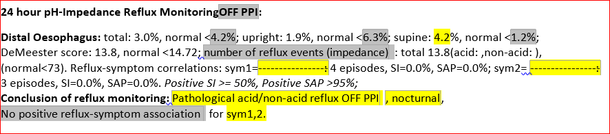

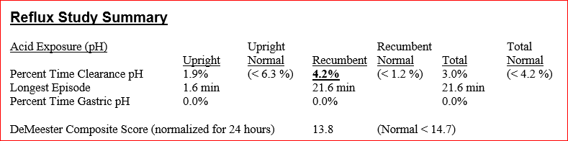

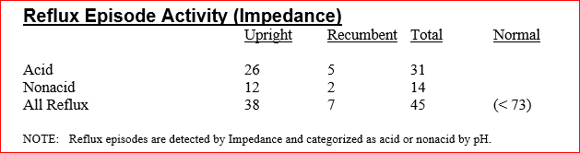
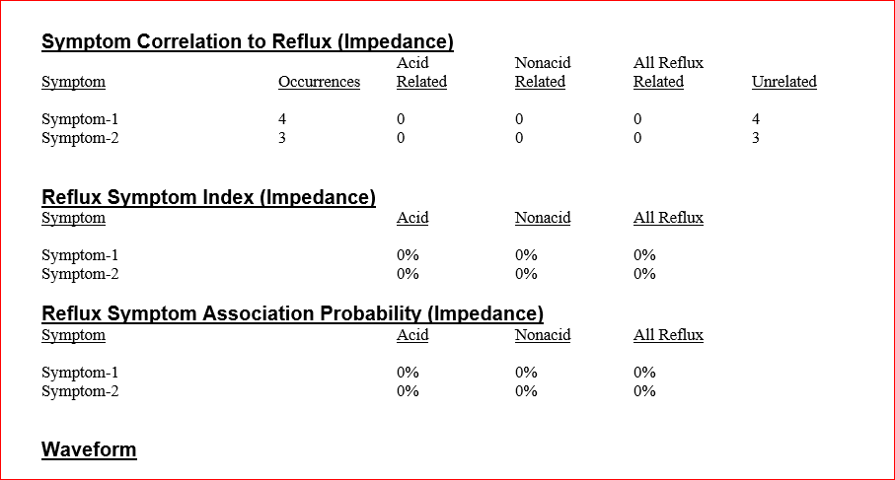

These two will need to be replaced by the following:
Pathological acid/non-acid reflux, OFF PPI or OFF PPI as a dropdown to choose.

Pathological acid/non-acid reflux:
IF
total: NNNN >;
OR
upright: MMMM >;
OR
supine: HHHH >;
OR
: total BBB >73
OR
Any combination of the above with one being positive

These two will need to be replaced by the following:
No pathological acid/non-acid reflux, ON PPI or ON PPI as a dropdown to choose.

No pathological acid/non-acid reflux:
IF
total: NNNN <;
AND
upright: MMMM <;
AND
supine: HHHH <;
AND
: total BBB <73

-------------------------------------------------------------------------------------------
This should be repeated for each of symptoms:

sym1=: 4 episodes, SI=0.0%, SAP=0.0%;
for sym1,2.

sym1=:
***this yellow box needs to be dropdown to choose from (we need to discuss later)

for…
IF
SI
AND
SAP
are both not positive

for
IF
SI
AND
SAP
are both positive

for
IF
SI
OR
SAP
is positive (only one of them)

for
***we need to discuss this option later when other parts are working

